**5. Methodology (re: how the problem will be solved, and code developed).**

Agile is the project management style that we will employ because it will enable us to produce the product more rapidly and with fewer headaches. Agile is an iterative approach to software development, thus instead of depending solely on a "big bang" launch, our team will be aiming to create the work in manageable, small-scale increments. Due to the frequent evaluation of needs, plans, and results, our teams will have a flexible manner of adapting to change quickly.[1]

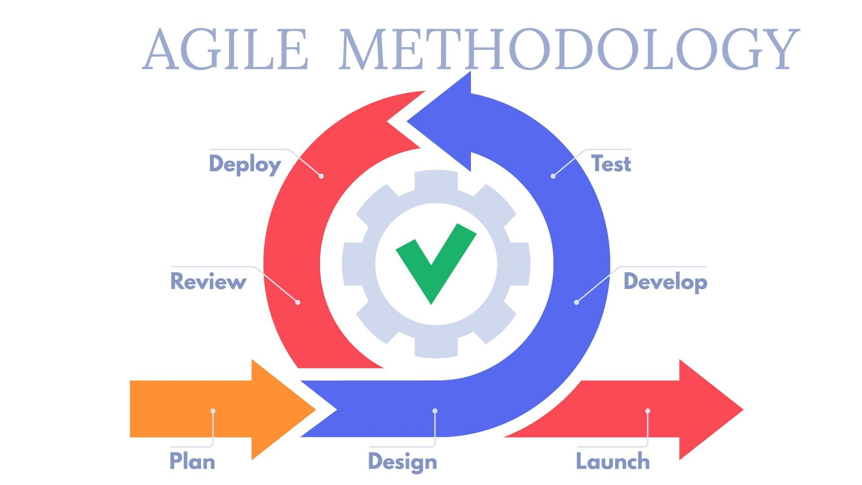[2]

To develop our code, we will first plan by gathering and analyzing the requirements, designing the software, developing, or coding it, testing it, deploying it, and reviewing it. This will be done in iterations to make sure that the software meets the requirements. If the requirements are met, it will be then released or launched for use.

**6. Work Plan (what will you complete by what time, including task distribution among group members).**

As we will be agile, we will be having a complete project developed iteratively between 23rd November 2022 and 12th December 2022(19 days). A detailed plan, requirement gathering, and analysis are estimated to take 5 days, design is projected to take 1 day, the development will take 5 days, 2 days for testing, and 6 days for deployment and review to see if the product meets the requirements.

# References

**There are no sources in the current document.**